**You must use the following:**

* Create a Database Instance with the following specifications:
  + Database creation method: Standard Create
  + Engine: MySQL
  + Database Instance size: db.t2.micro

**Following requirements should be met:**

* Follow the above-mentioned specifications
* Make sure that the Availability Zone is similar throughout the instances and volumes
* Ensure that the server scales automatically and the traffic is optimally routed among the scaled servers
* Document the step-by-step process involved in completing this task

Select Amazon RDS Managed Relational Database Services

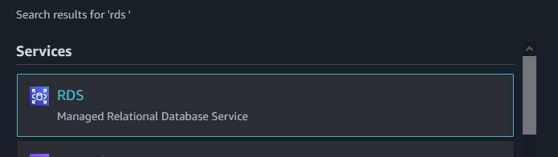

Press Create database button

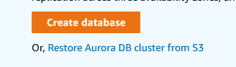

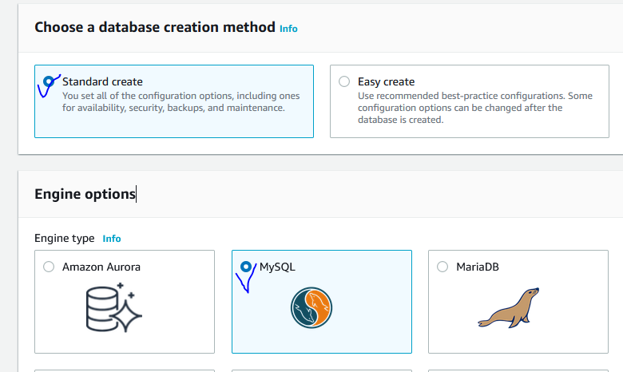

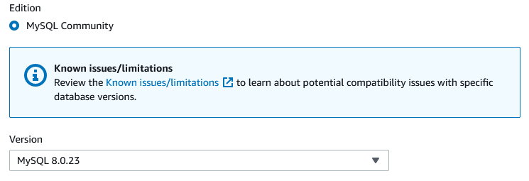

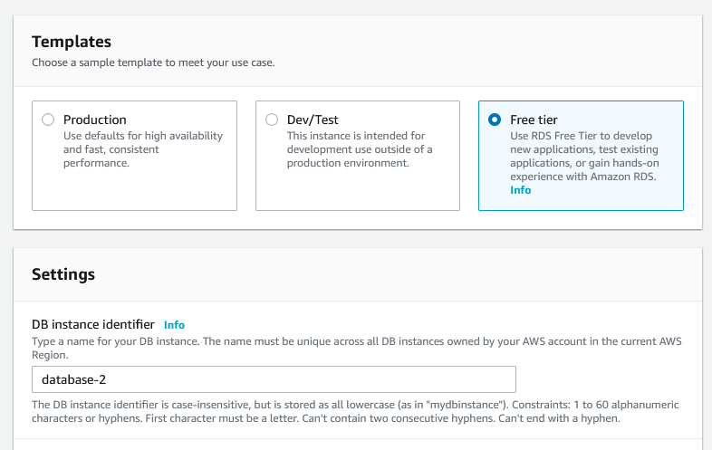

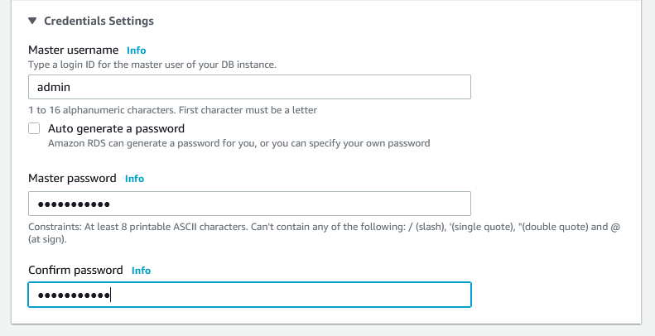

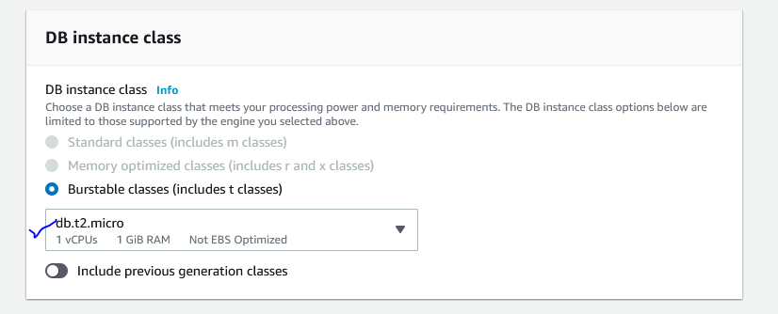

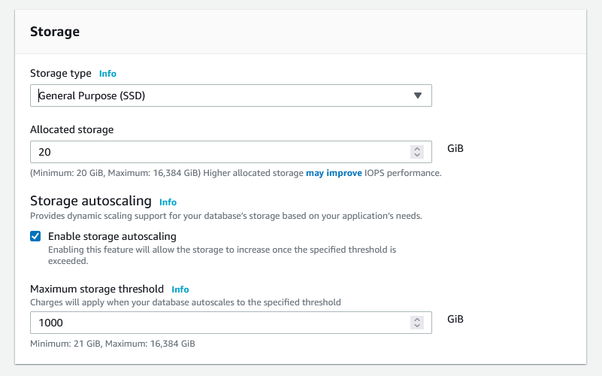

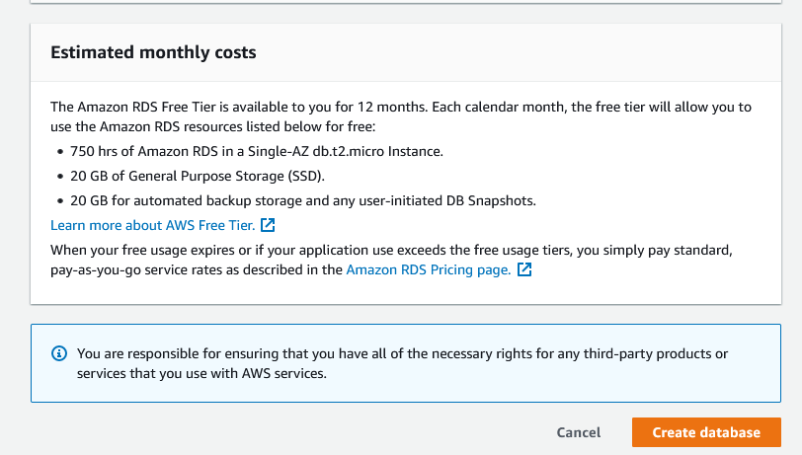

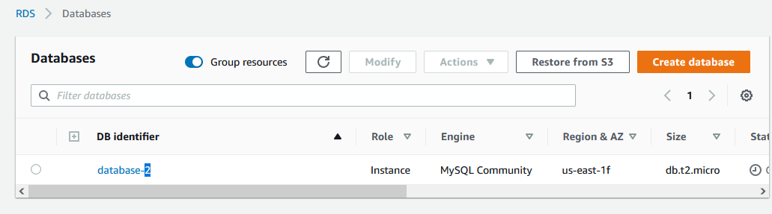

* Create an EC2 Instance with the following specifications:
  + AMI: Amazon Linux
  + Region: Use only US East (N Virginia), us-east-1, and us-east-2
  + Instance types: t2.micro and t3.micro
  + Allowed EBS types: GP2 and Standard

Type EC2 and launch EC2 Instance

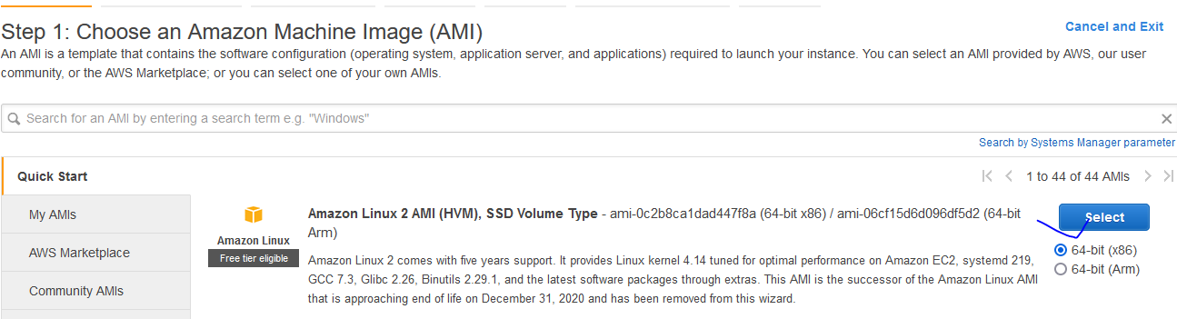

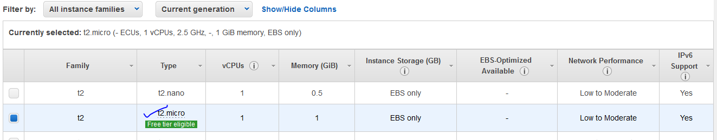

Next Configure Instance Details

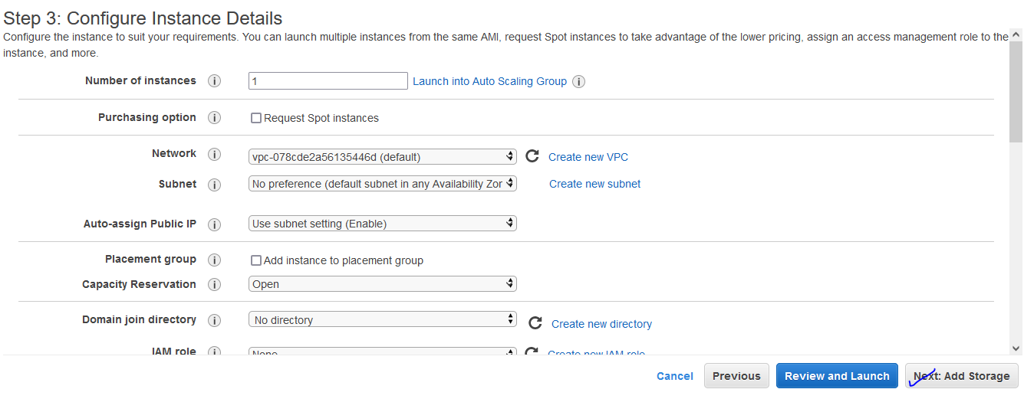

Add Magnetic Volume

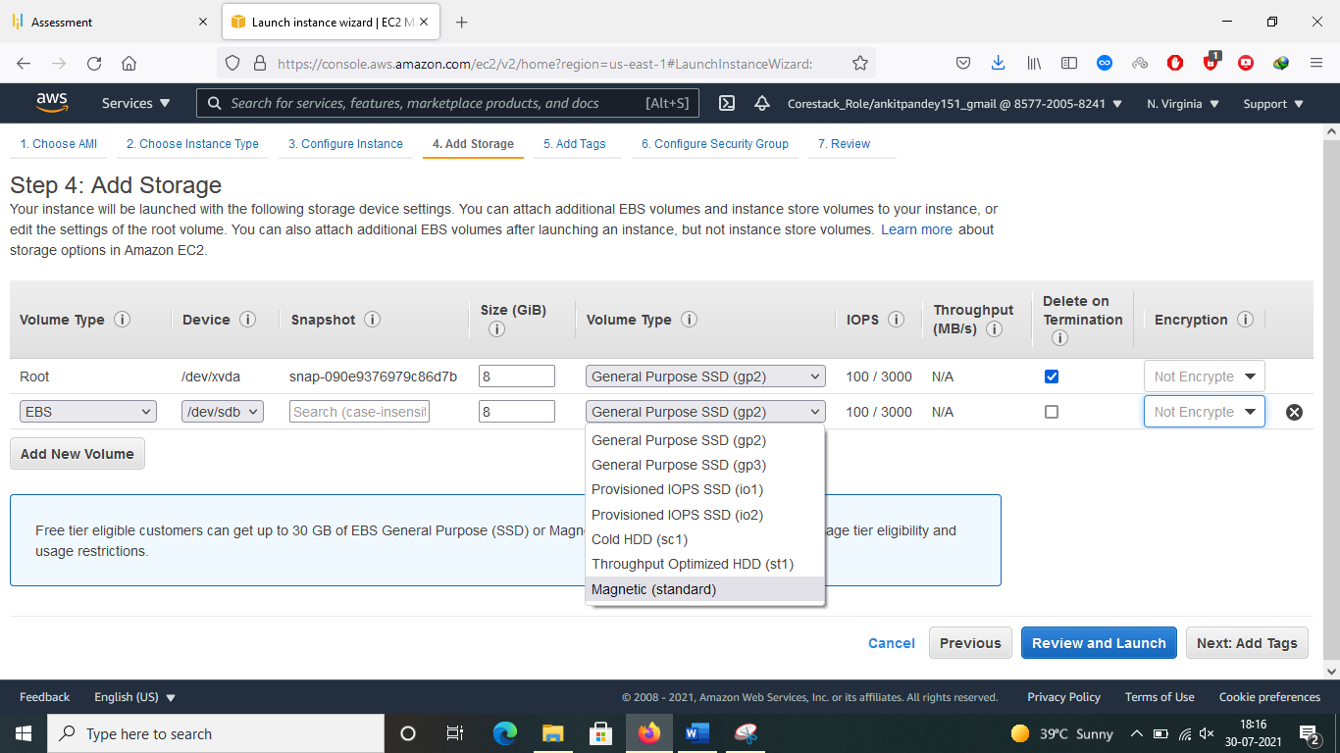

Storage Volume Details

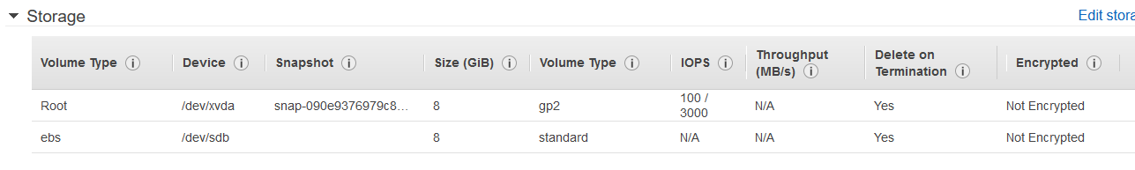

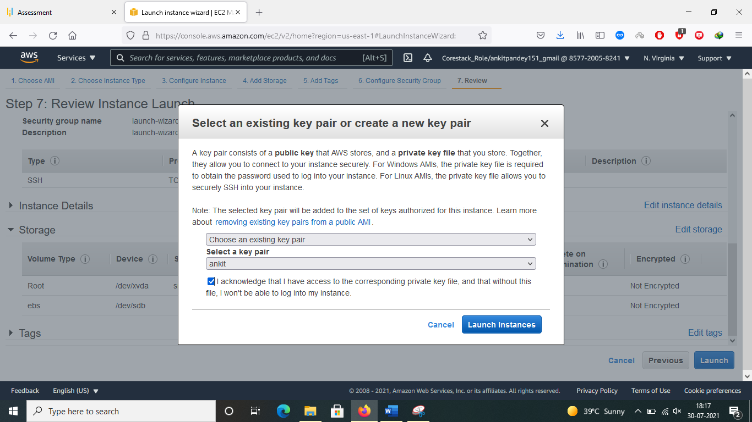

Selected AZ

